Pre-Search Pattern One

* **a name for the pattern: AutoSuggest & AutoFill**
* **a wireframe picture**:

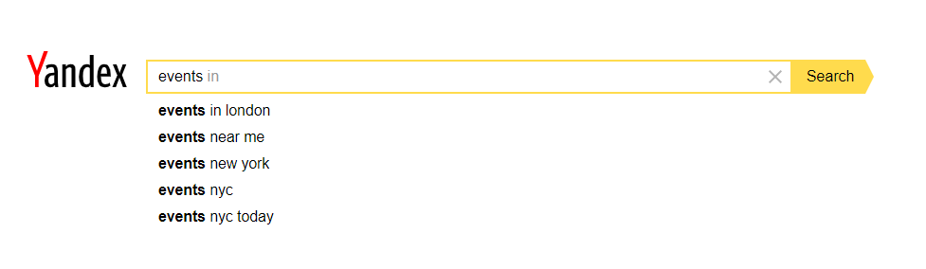

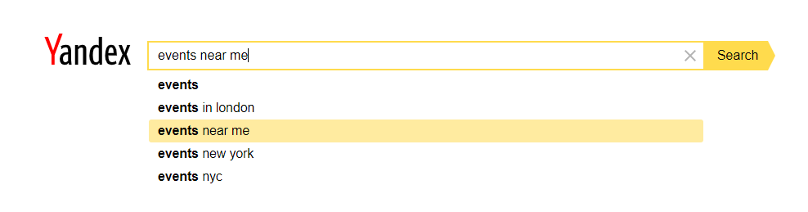

* **use when**:

1. Use when the user doesn’t have the exact knowledge of what he is looking for.
2. Use when user input match popular search requests
3. Use when user wants to know what other users are looking for.
4. Use when user wants to save time and spell the words correctly
5. Use when a search request can be entered in multiple ways.

* **how**

The idea is to display the most popular search requests that starts with the same combination of letters/words typed by user. User can select one of the options and the system will automatically fill the search bar with the selected search term/phrase. Also, this search pattern helps when the user is not very sure of what is he trying to search for by auto suggesting some popular options.

* **a discussion of** how you have applied this pattern in your own information seeking.

Autosuggest and Autofill is a great pattern, it is helping me daily by saving my time while I am typing. Most of the times it suggests the thing that I am trying to type, that is why all I need to do is select the search phrase from the list, and the search field automatically fills with the right, perfectly spelled words. Sometimes I am using this pattern to look for more specific information. For example, I might start typing a phrase, then analyse the suggested terminations and select the one in which I am interested in.

I am going to implement this pattern in my own information seeking system by suggesting popular search options, prioritized in the following order. First, the system is going to suggest name of the cities/towns/areas based on user’s input. Next search options that are going to appear are names of categories. The bottom search options are going to be the names of events. So, for example the user starts typing “Pa”, the system is going to suggest the following search options. In the top: “Paddington, Paisley” (names of towns), in the middle “Parties” (category name), at the bottom “Party Hard, Partying the whole Night” (names of events).